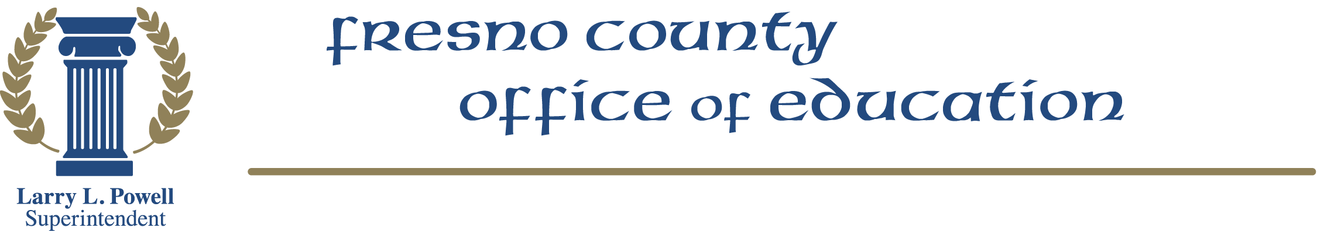
1111 Van Ness Avenue • Fresno, California 93721-2000
(559) 265-3000 • TDD (559) 497-3912 • Web Site: www.fcoe.org
Fresno County Office of Education
Board/Cabinet Seminar
April 27, 2012
Scout Island

“Planting Seeds for the Future”
Agenda

8:30-8:45 a.m. | Continental Breakfast
8:45-9:15 | Messages from the Board President and Superintendent |  | Barbara Thomas  Larry Powell
9:15-9:45 | Financial Forecast |  | Rick Martin
9:45-10:15 | Branding FCOE: In Search of a Perfect Tagline |  | Armen Bacon
10:15-10:30 | Break
10:30-11:00 | SB48 Update |  | Larry Powell
11:00-11:30 | The Foundation @ FCOE:  Supporting the Future | Dr. Michele Cantwell-Copher
11:30-12:30 | Lunch
12:30-1:00 | Special Presentation: Visit to new potting shed/nursery |  |  |  | Jan Biggs
1:00-1:30 | Common Core Standards—An Epic Time in Education |  | Di Leonardo  Director of ASIST
1:30-2:15 | ARTS Learning: Assessing What Matters |  |  | Bob Bullwinkel
2:15 | Closing Remarks |  |  |  | Larry Powell

